Maintenance Mangement Application
The basic aim of this application is to improve the management of product repairing process. This application will work for any category of products. The product to be repaired may be a mobile or a television or car or anything. The repairing shop may have one or more branches and this application can be used to manage all branches.GUI of this application will be responsive so that users can easily access it from web browsers.

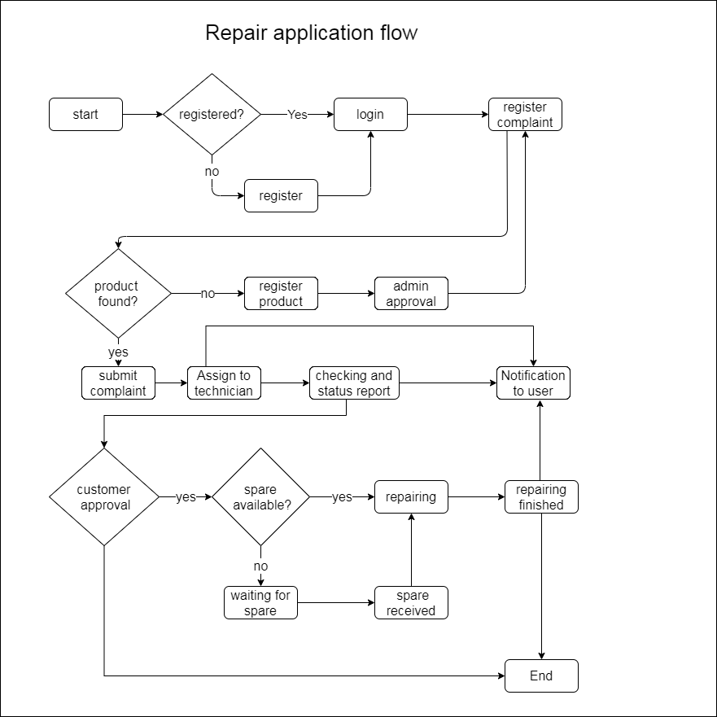

- Targeted users
  - Repair shops with a single location.
  - Repair shops with multiple locations under the same management.
- Database
Database should capable of storing multiple type of products like electronics,automobile,household etc. We can implement a centralized database to store all details and local database to store data when the internet is breakdown. When the connection is back we can sync these two databases.
- User creation
Users can use social login (Google,Facebook,etc) or manual signup and login process to use this application. Social Login is single sign-on for end users. Using existing login information from a social network provider like Facebook, Twitter, or Google, the user can sign into this application instead of creating a new account specifically for this application. This simplifies registrations and logins for end users. If the user need to use the traditional way, there will be a signup and login form. User can fill the details in the signup page and submit their registration. After email/sms verification they can login into the application.

- User roles
There are 3 type of users.
  - Customer
Users who come to the shop to repair their products are belongs to this role. Customers can use social login or traditional way to login into the system. After login they can register repair request.
  - Technician
Technicians are the users who work in repairing process. Technician’s account can be created from admin or technicians can directly create an account as technician but only after admin approval the account will be active.
  - Admin
Admin can add technicians who will work on different jobs. Admin will approve the request to add user’s product if it is not in the database. Repair request from user will come to the admin panel then admin will assign those works to different technicians.

- Repair registration
For register a new repair request, users must have logged into the system by using either social login or traditional way. Users can search and select their product in the application during the repair request registration. If the product is not found, he/she can add the product and submit for admin approval. After the approval of admin customer can add the product in their repair request. After submitting the repair request the application will create a job id, by using this job id user can track their request.

- Choose/Add product
Users can search and select their product in the application during the repair request registration. If the product is not found, he/she can add the product and submit for admin approval. After the approval of admin customer can add the product in their repair request.
- Change status of repair request
Admin will assign the job to the technician. Technician will start working on it and technician can change the status when the repair process status changed. The possible status are booked in, waiting for parts, repairing, completed.
- Email/sms notification
Customer will receive the status change notification through sms and email.

Initial phase

In the initial phase of this application, we will setup the login, signup pages and integrate the social login into this system.

/////////////////////////////////////////////////////////////////////////////////////////////////////////////////////////////////////////////////////////
- Discussion about the Repair project database structure and application features.

Discussion points
The discussed points in meeting are given below.
- Database
  - In the database both the product and customer table is taken from the Unicenta database. We can modify and add fields, tables etc. if required.
  - product table : what product is going to be repaired, we can also store accessories and parts in this table.
  - customer table : customer details
  - repair table : storing the repair information
  - repair_parts table : parts used for a particular repair.
  - repair_accessoriestable: accessories left by the customer. e.g.: charger, laptop bag
  - repair_faults table : faults of corresponding repair request.
  - repair_jobs table : jobs to be done in order to solve the faults of the corresponding repair request.
  - jobs table : common repair jobs, If anything new, it will be added to this table.
  - faults table : common faults. If anything new, it will be added to this table
- Application features
- After the social login if any details are missing we can ask to the user to fill the data.
- Admin user can change the role (user to technician and vice versa), add product and add category.
- This application should be applicable in different product repair shops but we can start with basic categories and basic fields.
- Users can view status, cost estimate, collected items, repair history.
- The part used for a particular job will be added to the billing.

- At the beginning stage we have to develop

  - user login
  - save customer info to the database
  - add product info by user if product not found (after admin approval).
- Existing system(Client already have)
- Existing system is a shared excel sheet to store and update data.
- Fields of the excel sheet are given below

  - date- date of repair request generated
  - job no- job number generated for particular repair job
  - item type- type of product like laptop,mobile,tablet etc.
  - model- Model number of the product
  - make -brand name
  - fault- From customer side
  - diagnostic information- actual problem. Generated by technician after inspection
  - repair cost- cost estimate of repair cost.
  - status-booked,repairing,waiting for parts,return,collected,finished.
  - parts- parts used for repair
  - accessories-accessories given with the product like charger,laptop bag etc.
  - name of the customer
  - phone number
  - email
////////////////////////////////////////////////////////////////////////////////////////////////////////////////////////////////////////////////////////

Required forms and tasks

  - user sign up from
  - loginfrom
  - user details after sign up (if social login, we can ask required details to users)
The fields that we will get after the social login are given below.
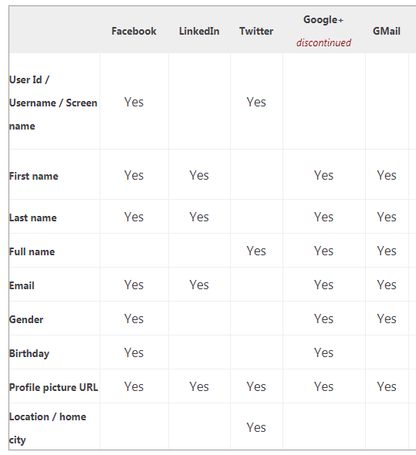

  - product add form
  - Repair request form

/////////////////////////////////////////
Changes required

Search product then register complaint
Admin will assign
Repairing notification
If the product add is rejected go to end

